5th lecture
5. Capacitance and capacitors
5.1 The concept of capacitance
Let us regard two conductors (e.g. two metal pieces), which are close to each other:

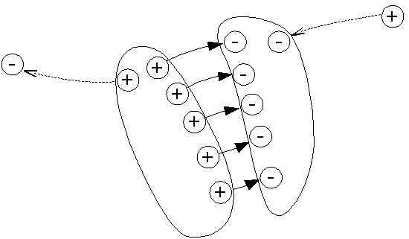

Figure 5.1
A charged capacitor

Let the electric charge on the first conductor +Q while –Q on the second one. In the following such a system will be called as electric capacitor or condenser. (The latter is considered an antiquated term in English, but most other languages use an equivalent, like the German word "Kondensator" or the Hungarian expression: „kondenzátor”.) Q is the charge of the capacitor. As we can see the charge of the capacitor is not the sum of the charges on its two plates (this is the name of the two conductors of the capacitor) but it is the charge of the positive plate only. If the two plates are close enough then the majority of the E lines originating from the postive plate ends at the negative one and the majority of the E lines ending at the negative plate are coming from the positive one. This way any E lines coming from, or going to, the surroundings of the capacitor can be neglected.
What is the voltage of a capacitor? Obviously, this is the voltage between its positive and negative plate. As we know the electric voltage between two points A and B can be calculated as
U_{AB}= $\int_{A}^{B}{}$E•dr
When we calculate that voltage of a capacitor, however, it is a convention (norm), that the starting point A of the line integral is always at the positive plate and the end point B is at the negative plate. As the conductor plates are equipotential point A can be anywhere on the positive plate and point B on the negative one. Following this convention the voltage U of a capacitor is always positive.
If the charge of a capacitor is doubled then, according to the first law of electrostatics, the number of E lines between the positive and negative plate should be also doubled. This way the density of the E lines and the magnitude of the electric field strength is doubled at each point between the two plates. If E in the path integral is doubled at each point then the calculated voltage should also increase by a factor of two. From this example we can see that the voltage between the two plates is proportional with the charge Q of the capacitor:
U = k⋅Q
The reciprocal of the proportionality factor k is usually denoted by C and it is called as the capacitance of the condenser:
k = 1/C ⇒ U = (1/C)⋅Q,
or
Q = C⋅U.
That is the larger the capacitance of a condenser the more charge can be stored in it at a given voltage.
The SI unit of the capacitance is the Farad:
1 Farad = 1 Coulomb/Volt ⇒ F = A⋅s/V.

5.2 The capacitance of the parallel plate, spherical and cylindrical capacitor
As it was discussed in the previous paragraph a pair of conductors with any shape can form a capacitor. The capacitance of the condenser will depend on the shape and the position of the plates and also on the material occupying the space between the plates. For the time being it will be assumed that the plates are in vacuum. In this case the capacitance will depend only on the geometry of the plates. Among the various possible geometries 3 special cases will be discussed: the parallel plate, the spherical and the cylindrical capacitor.

The parallel plate capacitor
Schematic views of a parallel plate capacitor are shown in Fig. 5.2

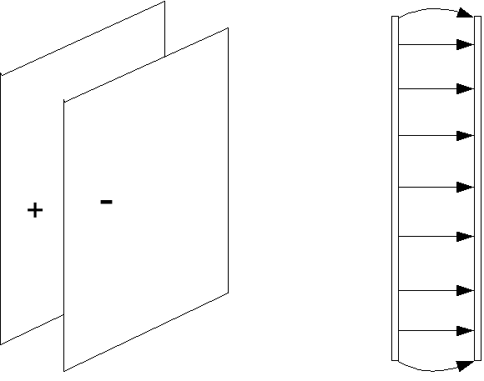

Figure 5.2 Schematic picures of a parallel plate capacitor
a) axonometric view b) crossectional view

Thus the parallel plate capacitor living up to its name consists of two parallel plates each with a surface area A separated by a distance d. It is important that the distance d be small compared to other sizes of the capacitor. This ensures that the electric field within the two plates is homogeneous. It is true that at the edges of the plates the electric field is inhomogeneous ( as some E are not parllel there ) but this region of the space is not significant is d is relatively small. Thus when we calculate the capacitance of the parallel plate capacitor we will assume that the electric field is homogeneous within the condenser.
$C=\frac{Q}{U}\text{.}$Let us calculate then the capacitance of a parallel plate condenser! The capacity of a condenser according to the definition is the charge of the capacitor divided by its voltage:
We can assume that the charge is distributed homogeneously on the surface of the plates thus the charge of the positive plate can be written as:
$Q=A σ\text{.}$According to the first law of electrostatics for a conducting surface:
$σ=D\text{.}$In vacuum the D can be written as the product of the permittivity of the vacuum ε₀ and the electric field strength E:
$D=ε_{0} E\text{.}$
consequently for a parallel plate capacitor
$Q=A ε_{0} E\text{.}$

In a homogeneous electric field the voltage between the plates:

$U= E d\text{.}$
Substituting the Q and U into the formula for the capacitance:
$C=\frac{Q}{U}=\frac{A ε_{0} E}{E d}=\frac{A ε_{0}}{d}\text{.}$
According to the above formula the capacitance of a parallel plate capacitor is proportional with the area A of the plates and inversely proportional with their distance d.
The result can be demonstrated with an experiment (Figure 5.3) where one plate of a capacitor is connected to the metal disc (the sensitive point) of a so called Braun electroscope and the other plate to the shield of the electroscope (which is usually grounded).

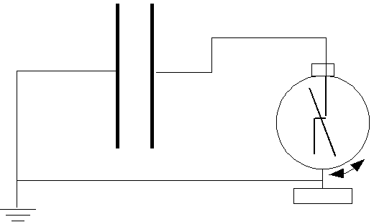

Figure 5.3 Measuring the voltage of a charged parallel plate capacitor
while changing the distance between the plates

First we charge the capacitor (and the elctroscope ) e.g. by a positively charged rubbed glass rod. Then the electroscope shows a medium voltage (200- 500 V). Next we near the plates of the capacitor and the voltage of the condenser (displayed by the electroscope) decreases because
U = Q/C
and the capacitance increasing by nearing the plates. When the distance d between the plates is increased the capacitance gets smaller and the voltage U, and the deflection of the Braun electrometer increases.
As we can see the electroscope is able to measure not only charge but voltage too. This is beacuse the electroscope itself can be regarded as a capacitor with two plates: one is the the central metal rod with the deflection arm while the other is the cylindrical shield which is isolated from the metal rod. Thus the higher the charge Q on this electrometer-capacitor, the higher also the voltage U there according to the formula above. Cosequently the scale of an electrometer can be calibrated for charge or voltage as well. Usually it is calibrated for Volts because in many experiments the electrometer is applied as an electrostatic voltmeter.
We remark that when the voltage of a capacitor is measured by an electroscope some charge is needed to charge the electroscope itself. Thus the measurement will decrease the charge of the capacitor. To minimize this loss the capaitance of the electrometer should be much smaller than that of the capacitor.

The Braun electroscope
The Braun electroscope that is used with various experiments in class is a deflection arm electroscope, as illustrated in Figure 5.3. The electroscope is constructed of a metal disc conected to a metal rod inside a circular cylindrical shell. The metal rod is insulated from the shell by a rubber gasket. The purpose of the outer cylindrical shell is to shield the electroscope from external charge influences. A deflection arm which has a metal pin through close to its center of gravity is connected directly to the metal rod. The deflection arm is free to rotate about its center axis. The metal rod is also bent such that the gravitational force acting on the deflection arm will result in the arm to reside vertical, yet on the right side of the metal rod at the top and the left side at the bottom.
Assume a positive-charged probe is touched to the metal disc, then these positive charges will be conducted to metal rod and distributed on the surface of the metal rod and the deflection arm. Then Coulomb forces result in a repulsive force between the like positive charges. This then results in a clockwise directed torque on the deflection arm at the top and the bottem. The deflection arm is then rotated to a certain distance until the torque of the coulomb force is in equilibrium with the torque of the gravitational force acting on the arm. What actually happens, is that the arm goes through a simple harmonic motion, which is quickly damped out due to frictional forces, until such an equilibrium is reached. Of course, the amount of deflection will be proportional in some manner to the amount of charge on the electroscope.

The spherical capacitor

Let us regard now two concentric spherical shells as a capacitor (Fig. 5.4). Let the inner sphere the positive plate of the capacitor and the outer sphere the negative one.
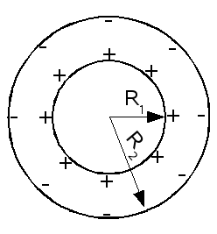

Figure 5.4
A spherical capacitor with inner radius R₁ and outer radius R₂

The electric field of a charged sphere outside of the sphere and the electric field of a point charge is identical if the charge of the sphere is equal to the point charge. This is because both field should be spherically symmetrical. Consequently for the field between the two spheres we can apply the formulas which we have already derived in the case of a point charge:

$E=\frac{1}{4{\text{πε}}_{0}}\frac{Q}{r^{2}}e_{r} \text{and} ϕ(r)=\frac{1}{4{\text{πε}}_{0}}\frac{Q}{r},$$ϕ(R_{1})=\frac{1}{4{\text{πε}}_{0}}\frac{Q}{R_{1}} \text{and} ϕ(R_{2})=\frac{1}{4{\text{πε}}_{0}}\frac{Q}{R_{2}}\text{.}$where r is the distance measured from the center of the concentric spheres. Consequently, if the radius of the inner sphere denoted by R₁ and that of the outer one by R₂ then their potential

Then the voltage between the spheres:

$U=ϕ(R_{1})−ϕ(R_{2})=\frac{Q}{4{\text{πε}}_{0}}\left[\frac{1}{R_{1}}−\frac{1}{R_{2}}\right],$

Thus the capacity of the spherical condenser can be expressed as
$C=\frac{Q}{U}=\frac{4{\text{πε}}_{0} R_{1}R_{2}}{R_{2}−R_{1}}\text{.}$
Problems and questions:
- Let us compare the above formula with that of valid for the parallel plate capacitor! How can we approximate the capacity of a spherical condenser when the two spheres are very close to each other?
- What is the capacity of a spherical condenser where R₂ → ∞ ?

The cylindrical capacitor
The scheme of a cylindrical capacitor can be seen in Fig. 5.5

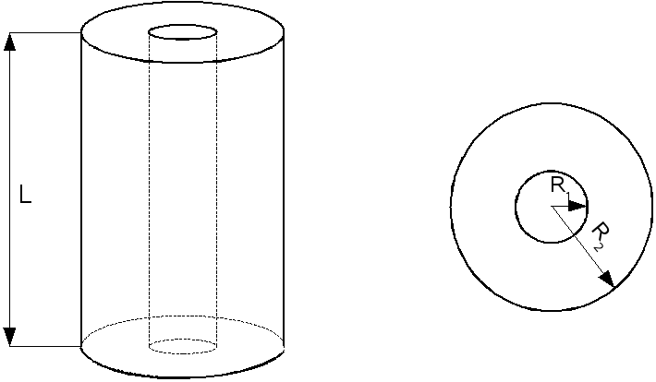

Figure 5.5 The geometry of a spherical cylinder

The capacitance of a condenser consisting of two concentric cylindrical shells with the length L is:
$C=\frac{2{\text{πε}}_{0} L}{\text{ln}({R_{2}}/{R_{1}})},$
where R₁ and R₂ are the radii of the inner and outer cylinder respectively.
This formula can be obtained by applying the first law of electrostatics to derive the electric field strength E(r) in a cylindrical capacitor as a function of the position r. We can assume that the inner cylinder is the positive plate and the outer cylinder is the negative one. As the electric field strength can be calculated as the number of E lines divided by the area crossed by these lines, and the number of E lines starting from the inner cylinder is Q/ε₀ consequently
E(r) = (Q/ε₀)/2πr²
where r is the radius of an imagined cylinder between R₁ and R₂ where we want to know the electric field strength.

Next we have to calculate the voltage U of the capacitor:

$U_{\text{KONDENZÁTOR}}=\int_{R_{1}}^{R_{2}}{E⋅dr},$We can chose a radial path for the calculation where

$E⋅dr=E⋅\text{dr},$
The last steps of the derivation are left to the reader as a practice in integration.

5.3 Combination of capacitors

Capacitors in parallel
We are talking about parallel connection when two or more componets in an electric circuit connects the very same two points. In this network the same voltage U apperas on these parallelly connected circuit components. It is a logical question whether these parallelly connected components can be substituted with a single one which is equivalent with the network of the single components. For example when we have three parallelly connected capacitors (see Fig. 5.6)
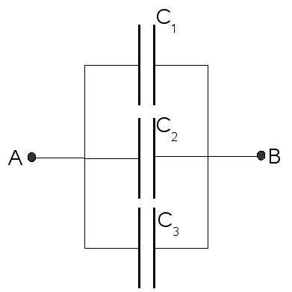

Fig. 5.6 A network of three paralelly connected capacitors
$C_{\text{EQUIVALENT}}=\frac{Q_{\text{EQUIVALENT}}}{U} Q_{\text{EQ}}=Q_{1}+Q_{2}+Q_{3}$the equivalent single capacitor should store the same charge as the three individual ones together at the same voltage. Based on that requirement the equivalent capacitance can be derived:
$C_{\text{EQ}}=\frac{Q_{1}+Q_{2}+Q_{3}}{U} C_{\text{EQ}}=\frac{Q_{1}}{U}+\frac{Q_{2}}{U}+\frac{Q_{3}}{U}=C_{1}+C_{2}+C_{3}\text{.}$
In general if we have n capacitors connected in parallel then the equivalent capacitance can be calculated as the sum of the individual ones:

$C_{\text{EQ}}=\sum_{i=1}^{n}{C_{i}\text{.}}$
Capacitors in series

As we have seen in the case of capacitors connected in series the volatge is the same on all of them because they connect the very same two points. When capacitors are connected in series (Fig. 5.7) then all capacitors have the same charge. This is because the negative plate of the first capacitor is connected to the positive plate of the second capacitor and so on: there is no branching point between the capacitors. Consequently if we give a positive charge to the first capacitor a negative charge will be attracted by electric induction to its other plate from the second capacitor. This way the first capacitor will have a negative charge on its negative plate but at the same time a positive charge appears on the second capacitor as the negative charge moved to the first capacitor by the electric influence. Thus a chain of electric influence will charge all the condenser. (The last plate is grounded see Fig. 5.7.)

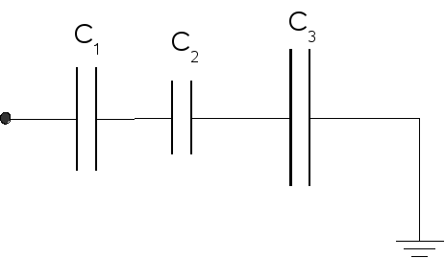

Figure 5.7 Capacitors connected in series
As the voltage on the serially connected capacitors is the sum of the voltages on the individual capacitors, consequently
$U_{\text{EQ}}=U_{1}+U_{2}+U_{3},$
$\frac{Q}{C_{\text{EQ}}}=\frac{Q}{C_{1}}+\frac{Q}{C_{2}}+\frac{Q}{C_{3}} ⇒ \frac{1}{C_{\text{EQ}}}=\frac{1}{C_{1}}+\frac{1}{C_{2}}+\frac{1}{C_{3}},$
or in general:
$\frac{1}{C_{\text{EQ}}}=\sum_{i=1}^{n}{\frac{1}{C_{i}}\text{.}}$
5.4 The energy stored in a capacitor. The energy of the electric field

The energy of a capacitor
$\text{dW}=U \text{dQ}\text{.}$ As we know the energy of a system is its ability to perform work. Thus we can determine the energy of a capacitor if we measure the work done by its electric field while the capacitor is discharged. If a small charge dQ is transferred from the positive plate to the negative one then the work done by the electric field on that charge is

here Q stand for the charge transferred from the positive plate to the negative one. (Thus the transferred charge at the beginning of the procedure is zero and after discharging the capacitor it is Q₀ , which is the initial charge of the capacitor.) The charge remaining on the capacitor is
$Q_{C}=Q_{0}−Q,$
and the voltage of the capacitor is
$U=\frac{Q_{C}}{C}=\frac{Q_{0}−Q}{C}\text{.}$$W=\int{\text{dW}=\int_{0}^{Q_{0}}{\frac{Q_{0}−Q_{C}}{C} \text{dQ}=}}\frac{Q_{0}^{2}}{C}−\frac{Q_{0}^{2}}{2C}=\frac{Q_{0}^{2}}{2C}\text{.}$Regarding the above formula the total work done by the electric field of the capacitor during its discharge:

Consequently the energy of a capacitor can be given by the following formulae:

$\frac{1}{2}\frac{Q_{0}^{2}}{C}=\frac{1}{2}U_{0}Q_{0}=\frac{1}{2}U_{0}^{2}C\text{.}$
$U_{\text{AVERAGE}}=\frac{1}{2}U_{0}\text{.}$The above result (including the multiplicator of ½) can be explained by the following simple argument. The voltage of the capacitor decrreases to zero during the discharge as a linear fuction of the charge remaining on it. Consequently the avearage voltage is the mathematical mean of the initial and final voltages:

Thus the work made by the electric field of the capacitor is

$U_{\text{AVERAGE}} Q_{0}=\frac{1}{2}U_{0} Q_{0}\text{.}$

The energy density of the electric field

In this paragraph we want to prove that the energy density of the electrostatic field in a given point of the space can be given as

ρ(energy) = (1/2)E⋅D

The validity of the above expression will be proven for the simple case of the homogeneous electric field in a parallel plate capacitor. (The expression is valid, however, for the energy density of any electric field.)
Let us regard then a charged parallel plate capacitor with a homogeneous electric field strength E. The the voltage of this capacitor is
$U=\int{E⋅dr}=E⋅d,$where d is the distance between the plates of the capacitor. The energy of a capacitor as we have derived in the previous paragraph:
$E_{\text{POT}}=\frac{1}{2}U^{2}C\text{.}$Let us substitute into the above formula the relation U=Ed, and the capacitance of the parallel plate condenser $C=\frac{ε_{0}A}{d}$, then we obtain
$E_{\text{POT}}=\frac{1}{2}(E d)^{2}\frac{ε_{0}A}{d}=\frac{1}{2}(E ε_{0}E)(A d)=\frac{1}{2}(E D)V$
where V is the volume of the parallel plate capacitor. Now we can express the enery density inside the capacitor:

$ρ(\text{energy})=\frac{E_{\text{POT}}}{V}=\frac{1}{2}E⋅D,$
which is the formula we were looking for.

